**1.Hello World RESTful Web Service**

**Controller**

package com.cognizant.springlearn.controller;

import org.slf4j.Logger;

import org.slf4j.LoggerFactory;

import org.springframework.web.bind.annotation.GetMapping;

import org.springframework.web.bind.annotation.RestController;

@RestController

public class HelloController {

private static final Logger LOGGER = LoggerFactory.getLogger(HelloController.class);

@GetMapping("/hello")

public String sayHello() {

LOGGER.info("START");

String message = "Hello World!!";

LOGGER.info("END");

return message;

}

}

**Application.java**

package com.cognizant.springlearn;

import org.springframework.boot.SpringApplication;

import org.springframework.boot.autoconfigure.SpringBootApplication;

@SpringBootApplication

public class SpringLearnApplication {

public static void main(String[] args) {

SpringApplication.run(SpringLearnApplication.class, args);

}

}

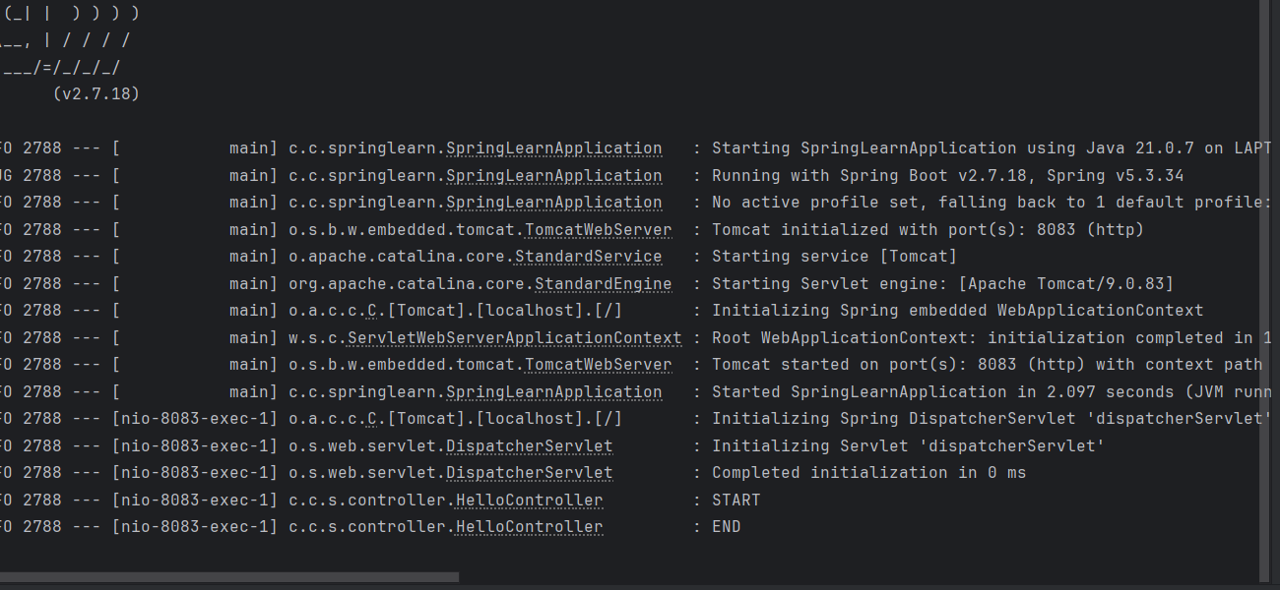

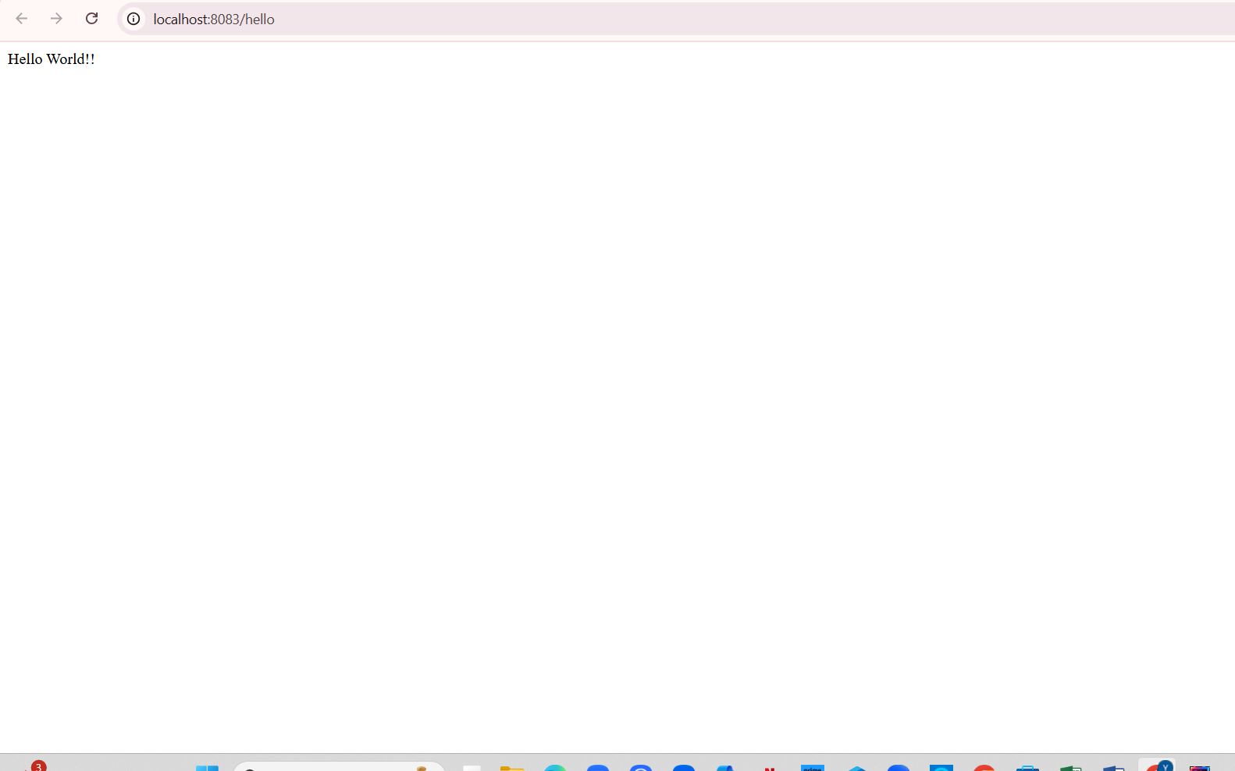

**2.REST - Country Web Service**

**Model.country.java**

package com.cognizant.springlearn.model;

public class Country {

private String code;

private String name;

public String getCode() {

return code;

}

public void setCode(String code){

this.code = code;

}

public String getName() {

return name;

}

public void setName(String name) {

this.name = name;

}

}

**CountryController**

package com.cognizant.springlearn.controller;

import com.cognizant.springlearn.model.Country;

import org.slf4j.Logger;

import org.slf4j.LoggerFactory;

import org.springframework.beans.factory.xml.XmlBeanFactory;

import org.springframework.core.io.ClassPathResource;

import org.springframework.web.bind.annotation.RequestMapping;

import org.springframework.web.bind.annotation.RestController;

@SuppressWarnings("deprecation")

@RestController

public class CountryController {

private static final Logger LOGGER = LoggerFactory.getLogger(CountryController.class);

@RequestMapping("/country")

public Country getCountryIndia() {

LOGGER.info("START");

XmlBeanFactory factory = new XmlBeanFactory(new ClassPathResource("country.xml"));

Country country = (Country) factory.getBean("in");

LOGGER.info("END");

return country;

}

}

**Country.xml**

<?xml version="1.0" encoding="UTF-8"?>

<beans xmlns="http://www.springframework.org/schema/beans"

xmlns:xsi="http://www.w3.org/2001/XMLSchema-instance"

xsi:schemaLocation="http://www.springframework.org/schema/beans

https://www.springframework.org/schema/beans/spring-beans.xsd">

<bean id="in" class="com.cognizant.springlearn.model.Country">

<property name="code" value="IN" />

<property name="name" value="India" />

</bean>

</beans>

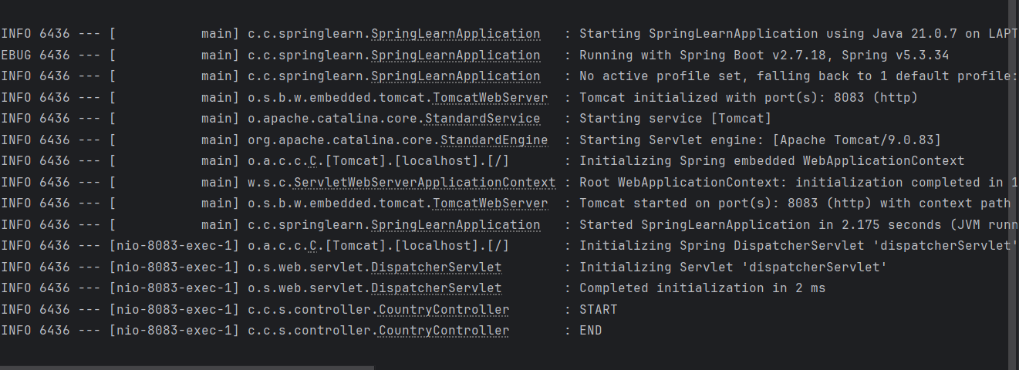

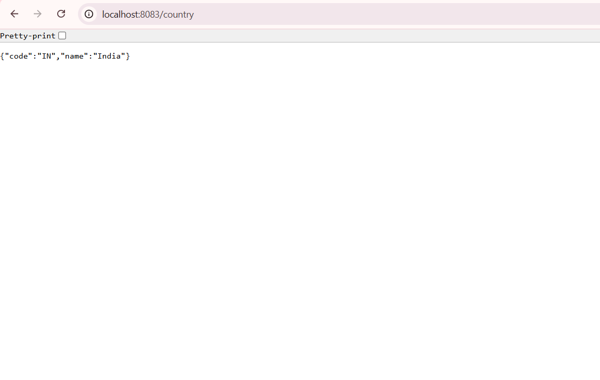

**3.REST - Get all countries**

**Country.xml**

<?xml version="1.0" encoding="UTF-8"?>

<beans xmlns="http://www.springframework.org/schema/beans"

xmlns:xsi="http://www.w3.org/2001/XMLSchema-instance"

xsi:schemaLocation="http://www.springframework.org/schema/beans

http://www.springframework.org/schema/beans/spring-beans.xsd">

<bean id="country" class="com.cognizant.springlearn.model.Country">

<property name="code" value="IN"/>

<property name="name" value="India"/>

</bean>

<bean id="countryList" class="java.util.ArrayList">

<constructor-arg>

<list>

<bean class="com.cognizant.springlearn.model.Country">

<property name="code" value="IN"/>

<property name="name" value="India"/>

</bean>

<bean class="com.cognizant.springlearn.model.Country">

<property name="code" value="US"/>

<property name="name" value="United States"/>

</bean>

<bean class="com.cognizant.springlearn.model.Country">

<property name="code" value="JP"/>

<property name="name" value="Japan"/>

</bean>

<bean class="com.cognizant.springlearn.model.Country">

<property name="code" value="DE"/>

<property name="name" value="Germany"/>

</bean>

</list>

</constructor-arg>

</bean>

</beans>

**CountryController**

package com.cognizant.springlearn.controller;

import com.cognizant.springlearn.model.Country;

import org.springframework.web.bind.annotation.GetMapping;

import org.springframework.web.bind.annotation.RestController;

import org.springframework.beans.factory.xml.XmlBeanFactory;

import org.springframework.core.io.ClassPathResource;

import java.util.List;

@RestController

public class CountryController {

@GetMapping("/countries")

public List<Country> getAllCountries() {

XmlBeanFactory factory = new XmlBeanFactory(new ClassPathResource("country.xml"));

List<Country> countryList = (List<Country>) factory.getBean("countryList");

return countryList;

}

}

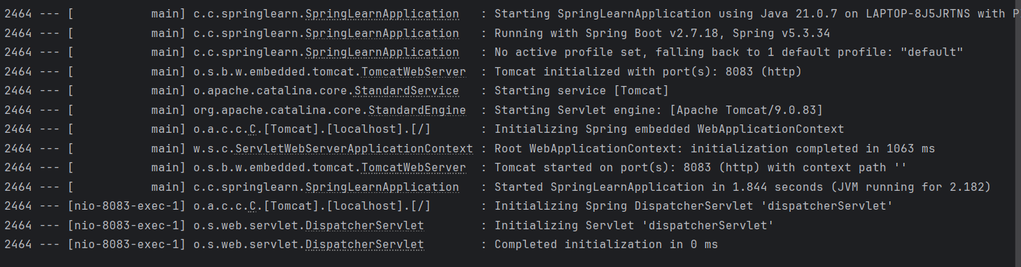

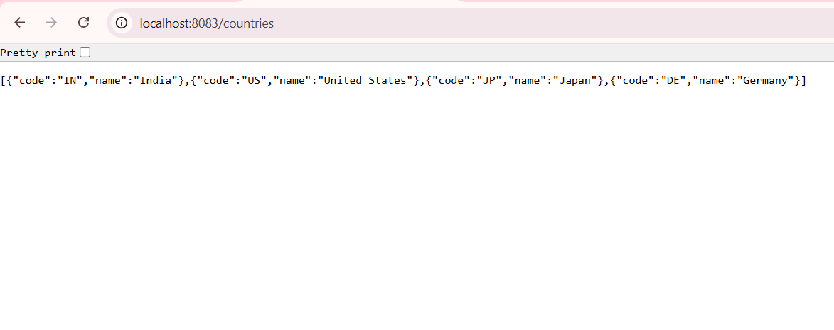

**4.REST - Get country based on country code**

**CountryService**

package com.cognizant.springlearn.service

import com.cognizant.springlearn.model.Country;

import org.springframework.beans.factory.xml.XmlBeanFactory;

import org.springframework.core.io.ClassPathResource;

import org.springframework.stereotype.Service;

import java.util.List;

@Service

public class CountryService {

public Country getCountry(String code) {

XmlBeanFactory factory = new XmlBeanFactory(new ClassPathResource("country.xml"));

List<Country> countryList = (List<Country>) factory.getBean("countryList");

return countryList.stream()

.filter(country -> country.getCode().equalsIgnoreCase(code))

.findFirst()

.orElse(null);

}

}

**CountryController**

package com.cognizant.springlearn.controller;

import com.cognizant.springlearn.model.Country;

import com.cognizant.springlearn.service.CountryService;

import org.springframework.beans.factory.annotation.Autowired;

import org.springframework.web.bind.annotation.*;

@RestController

public class CountryController {

@Autowired

private CountryService countryService;

@GetMapping("/countries/{code}")

public Country getCountry(@PathVariable String code) {

return countryService.getCountry(code);

}

}

**Country**

package com.cognizant.springlearn.model;

public class Country {

private String code;

private String name;

// Getters and Setters

public String getCode() { return code; }

public void setCode(String code) { this.code = code; }

public String getName() { return name; }

public void setName(String name) { this.name = name; }

}

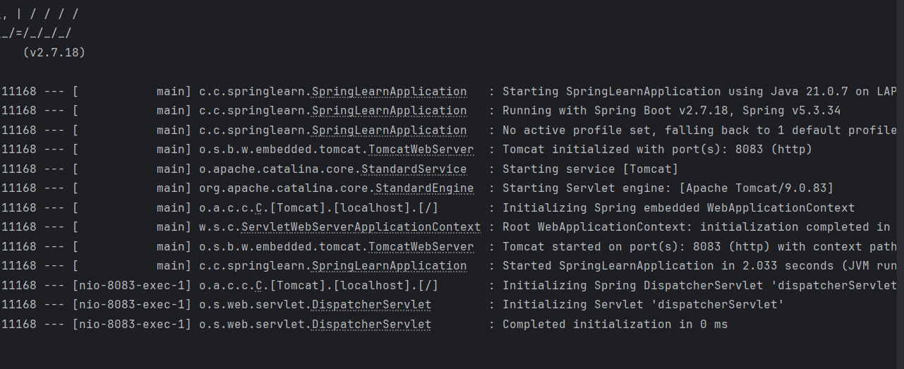

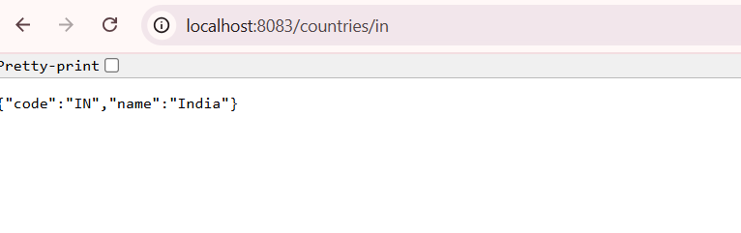 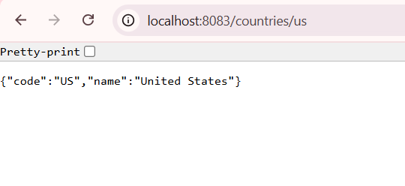

**5.REST - Get country exceptional scenario**

**CountryController**

package com.cognizant.springlearn.controller;

import com.cognizant.springlearn.service.exception.CountryNotFoundException;

import com.cognizant.springlearn.model.Country;

import com.cognizant.springlearn.service.CountryService;

import org.springframework.beans.factory.annotation.Autowired;

import org.springframework.web.bind.annotation.*;

@RestController

public class CountryController {

@Autowired

private CountryService countryService;

@GetMapping("/countries/{code}")

public Country getCountry(@PathVariable String code) throws CountryNotFoundException {

return countryService.getCountry(code);

}

}

**CountryNotFoundException**

package com.cognizant.springlearn.service.exception;

import org.springframework.http.HttpStatus;

import org.springframework.web.bind.annotation.ResponseStatus;

@ResponseStatus(value = HttpStatus.NOT_FOUND, reason = "Country not found")

public class CountryNotFoundException extends Exception {

public CountryNotFoundException(String message) {

super(message);

}

**}**

**Countryservice**

package com.cognizant.springlearn.service;

import com.cognizant.springlearn.model.Country;

import com.cognizant.springlearn.service.exception.CountryNotFoundException;

import org.springframework.beans.factory.xml.XmlBeanFactory;

import org.springframework.core.io.ClassPathResource;

import org.springframework.stereotype.Service;

import java.util.List;

@Service

public class CountryService {

public Country getCountry(String code) throws CountryNotFoundException {

XmlBeanFactory factory = new XmlBeanFactory(new ClassPathResource("country.xml"));

List<Country> countryList = (List<Country>) factory.getBean("countryList");

return countryList.stream()

.filter(c -> c.getCode().equalsIgnoreCase(code))

.findFirst()

.orElseThrow(() -> new CountryNotFoundException("Country not found"));

}

}

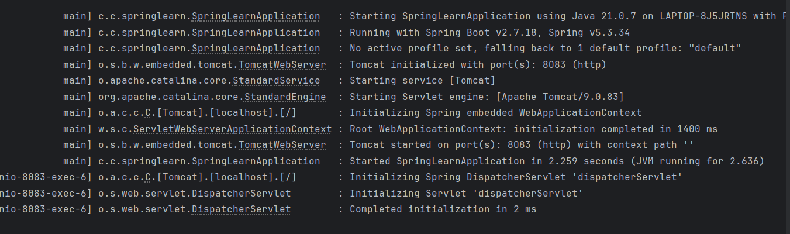

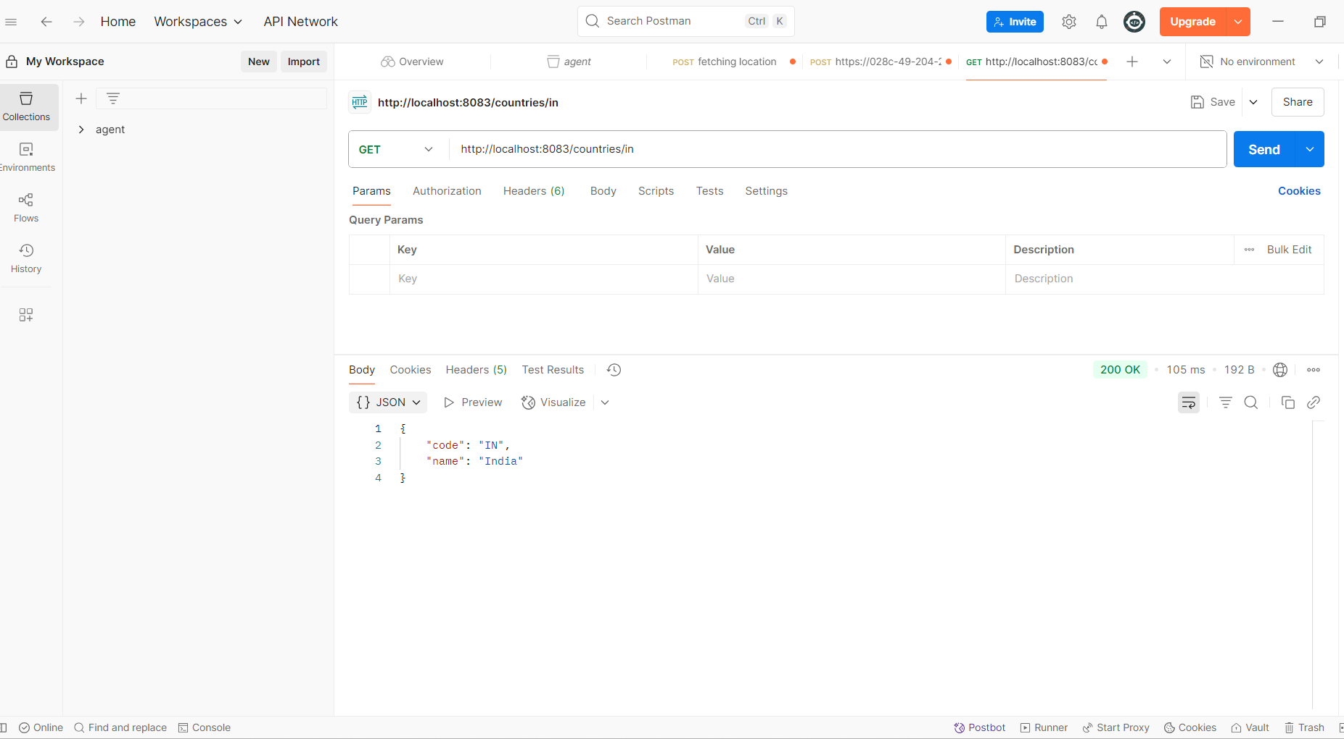

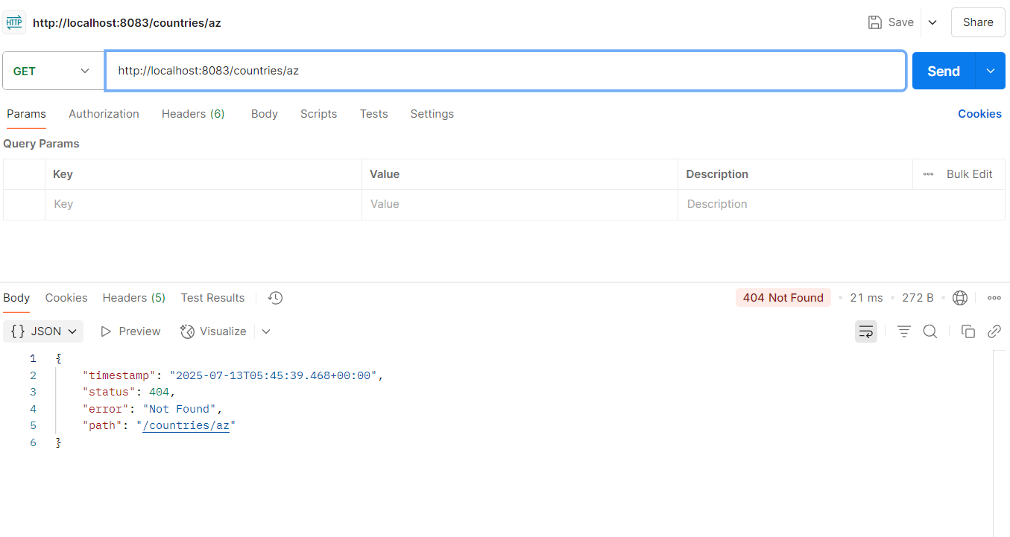

**6.MockMVC - Test get country service** 

**CountryControlller**

package com.cognizant.springlearn.controller;

import com.cognizant.springlearn.model.Country;

import org.springframework.web.bind.annotation.GetMapping;

import org.springframework.web.bind.annotation.RestController;

import org.springframework.beans.factory.xml.XmlBeanFactory;

import org.springframework.core.io.ClassPathResource;

import java.util.List;

@RestController

public class CountryController {

@GetMapping("/countries")

public List<Country> getAllCountries() {

XmlBeanFactory factory = new XmlBeanFactory(new ClassPathResource("country.xml"));

List<Country> countryList = (List<Country>) factory.getBean("countryList");

return countryList;

}

}

**Country**

package com.cognizant.springlearn.model;

public class Country {

private String code;

private String name;

// Getters and Setters

public String getCode() { return code; }

public void setCode(String code) { this.code = code; }

public String getName() { return name; }

public void setName(String name) { this.name = name; }

}

**Country.xml**

<?xml version="1.0" encoding="UTF-8"?>

<beans xmlns="http://www.springframework.org/schema/beans"

xmlns:xsi="http://www.w3.org/2001/XMLSchema-instance"

xsi:schemaLocation="http://www.springframework.org/schema/beans

http://www.springframework.org/schema/beans/spring-beans.xsd">

<bean id="country" class="com.cognizant.springlearn.model.Country">

<property name="code" value="IN"/>

<property name="name" value="India"/>

</bean>

<bean id="countryList" class="java.util.ArrayList">

<constructor-arg>

<list>

<bean class="com.cognizant.springlearn.model.Country">

<property name="code" value="IN"/>

<property name="name" value="India"/>

</bean>

<bean class="com.cognizant.springlearn.model.Country">

<property name="code" value="US"/>

<property name="name" value="United States"/>

</bean>

<bean class="com.cognizant.springlearn.model.Country">

<property name="code" value="JP"/>

<property name="name" value="Japan"/>

</bean>

<bean class="com.cognizant.springlearn.model.Country">

<property name="code" value="DE"/>

<property name="name" value="Germany"/>

</bean>

</list>

</constructor-arg>

</bean>

</beans>

**Test.java**

package com.cognizant.springlearn;

import com.cognizant.springlearn.controller.CountryController;

import org.junit.jupiter.api.Test;

import static org.junit.jupiter.api.Assertions.assertNotNull;

import static org.springframework.test.web.servlet.result.MockMvcResultMatchers.*;

import static org.springframework.test.web.servlet.request.MockMvcRequestBuilders.get;

import org.springframework.beans.factory.annotation.Autowired;

import org.springframework.boot.test.context.SpringBootTest;

import org.springframework.boot.test.autoconfigure.web.servlet.AutoConfigureMockMvc;

import org.springframework.test.web.servlet.MockMvc;

import org.springframework.test.web.servlet.ResultActions;

@SpringBootTest

@AutoConfigureMockMvc

public class SpringLearnApplicationTests {

@Autowired

private CountryController countryController;

@Autowired

private MockMvc mockMvc;

@Test

public void contextLoads() {

assertNotNull(countryController);

}

@Test

public void testGetAllCountries() throws Exception {

ResultActions result = mockMvc.perform(get("/countries"));

result.andExpect(status().isOk());

result.andExpect(jsonPath("$").isArray());

result.andExpect(jsonPath("$[0].code").value("IN"));

result.andExpect(jsonPath("$[0].name").value("India"));

}

}

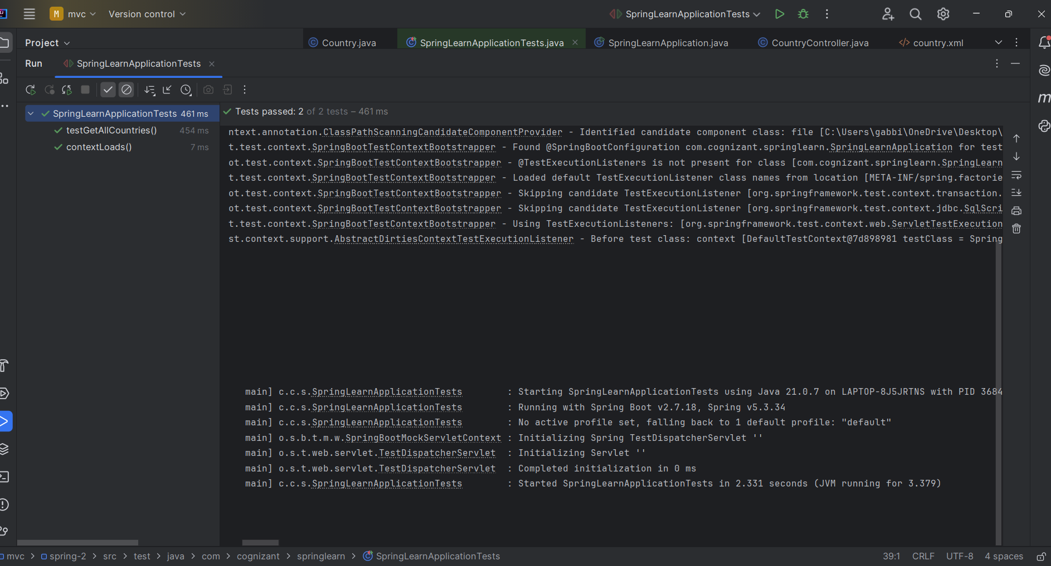

**7. MockMVC - Test get country service for exceptional scenario** 

**CountryException**

package com.cognizant.springlearn.exception;

import org.springframework.http.HttpStatus;

import org.springframework.web.bind.annotation.ResponseStatus;

@ResponseStatus(value = HttpStatus.NOT_FOUND, reason = "Country not found")

public class CountryNotFoundException extends Exception {

public CountryNotFoundException(String message) {

super(message);

}

}

**Tests.java**

package com.cognizant.springlearn;

import com.cognizant.springlearn.controller.CountryController;

import org.junit.jupiter.api.Test;

import org.springframework.beans.factory.annotation.Autowired;

import org.springframework.boot.test.autoconfigure.web.servlet.AutoConfigureMockMvc;

import org.springframework.boot.test.context.SpringBootTest;

import org.springframework.test.web.servlet.MockMvc;

import org.springframework.test.web.servlet.ResultActions;

import static org.junit.jupiter.api.Assertions.assertNotNull;

import static org.springframework.test.web.servlet.request.MockMvcRequestBuilders.get;

import static org.springframework.test.web.servlet.result.MockMvcResultMatchers.*;

@SpringBootTest

@AutoConfigureMockMvc

public class SpringLearnApplicationTests {

@Autowired

private CountryController countryController;

@Autowired

private MockMvc mockMvc;

@Test

public void contextLoads() {

assertNotNull(countryController);

}

@Test

public void testGetAllCountries() throws Exception {

ResultActions result = mockMvc.perform(get("/countries"));

result.andExpect(status().isOk());

result.andExpect(jsonPath("$").isArray());

result.andExpect(jsonPath("$[0].code").value("IN"));

result.andExpect(jsonPath("$[0].name").value("India"));

}

@Test

public void testGetCountryByCode() throws Exception {

mockMvc.perform(get("/countries/in"))

.andExpect(status().isOk())

.andExpect(jsonPath("$.code").value("IN"))

.andExpect(jsonPath("$.name").value("India"));

}

@Test

public void testGetCountryException() throws Exception {

mockMvc.perform(get("/countries/invalid"))

.andExpect(status().isNotFound());

}

}

